Hosting a Web server on Amazon

Contents

Getting started 2

Accessing the management console 2

Navigating the AWS Portal – Services Menu Button 3

# Getting started

You have been sent an email for access to an AWS training program:

* AWS Academy Learner Lab. This provides the console access to complete our learning and assessments

Log into AWS academy using the link provided in the email sent to your student account or via this link <https://awsacademy.instructure.com/login/canvas>

# Accessing the management console

|  |  |
| --- | --- |
| Select the “Modules” hyperlink at the bottom of the page |  |
| Select the “Learner Lab” module |  |
| You should get an agreement. Select “I agree”  If the agreement does not appear, click “Modules” again in the top left. |  |

|  |  |
| --- | --- |
| You are now in the lab environment, ready to start the lab.  Select “Start Lab” |  |
| The lab environment will take a while to power on |  |
| Once powered on, you will get a console similar to the right |  |
| Click the “AWS” link in the top left to access the management console. Make sure that the dot goes from **yellow** to **green** |  |

# Navigating the AWS Portal – Services Menu Button

1. Opening the AWS Portal, all the services we require are in the services menu. You access this by clicking on Services at the top left of the screen.

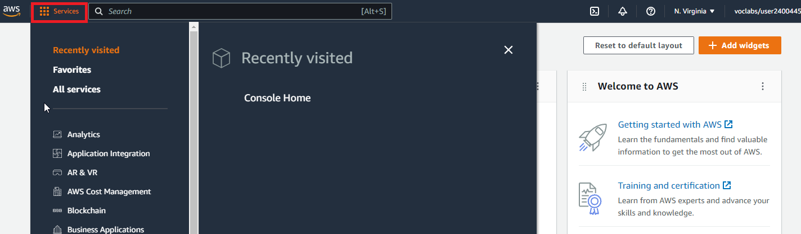

**EC2**

1. Click on Services Menu button.
2. Click on Compute
3. Click on EC2

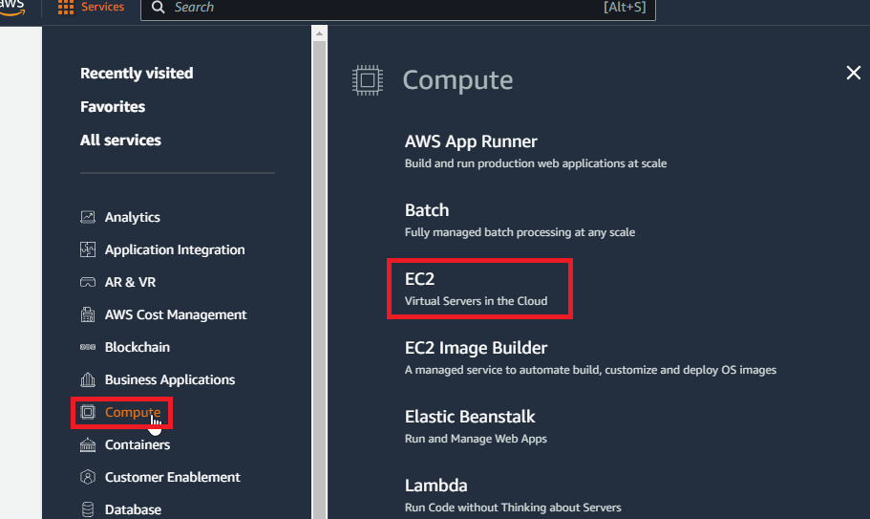

You will now be at the EC2 Dashboard

Click around each of the menu items on the left-hand side and see what information they contain

Is there anything currently set up?

Go through each of these services, look around the dashboard and click on the menu items to see what is available in each service and what is currently running or created

* Storage -> S3
* Compute -> Lambda
* Database -> RDS
* Machine Learning -> Amazon Lex
* Machine Learning -> AWS DeepRacer

Click around any other services that take your interest. You might be able to create something, or you may not have permission. This is a practice portal so have a go